ELECTRONIC PRESS KIT

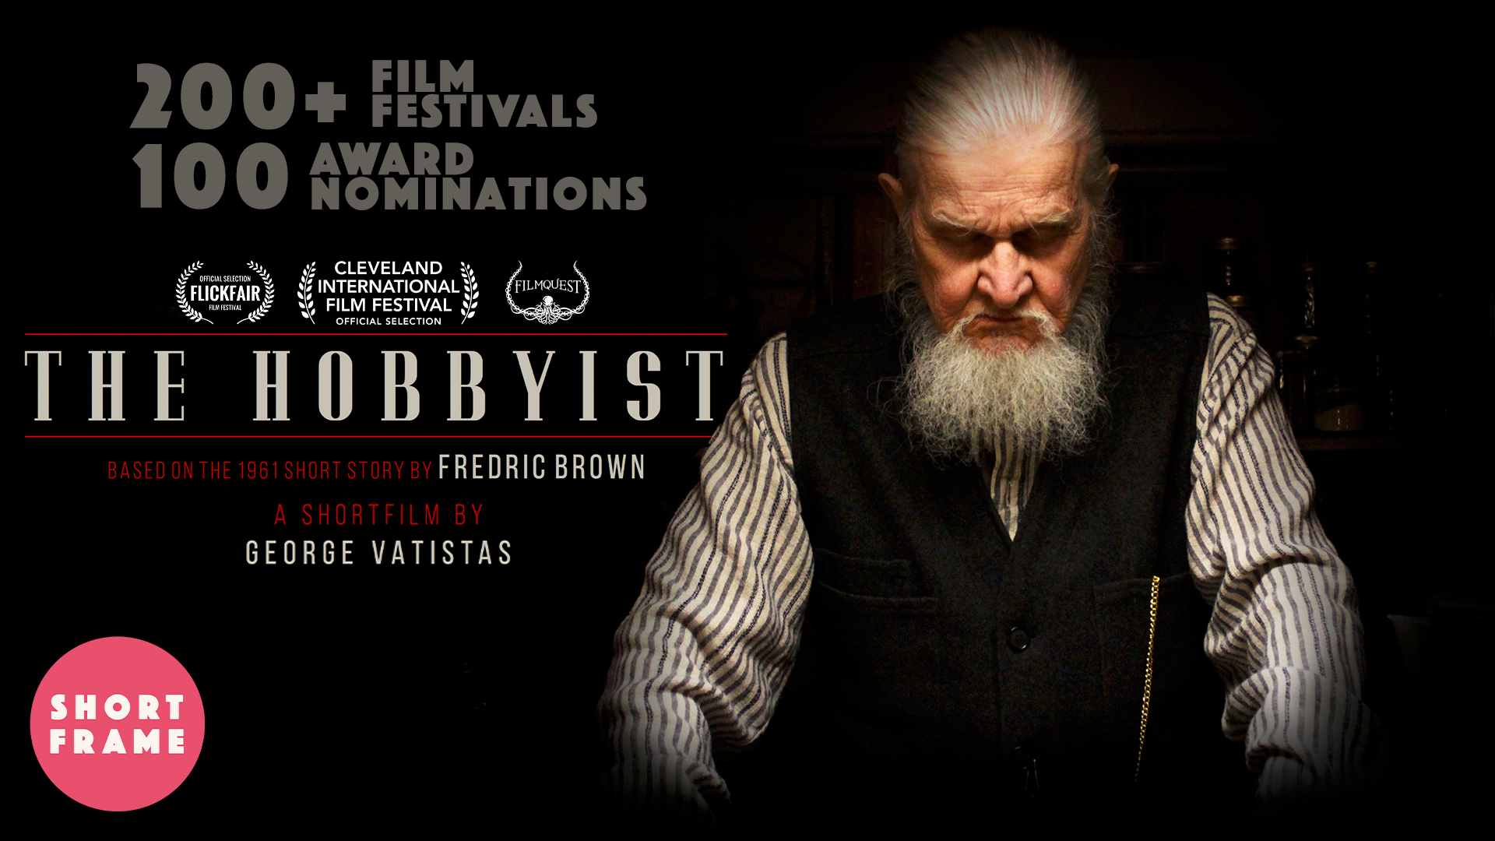

WRITTEN & DIRECTED BY:
GEORGE VATISTAS

PRODUCED BY:
D. M. NIGHT MAIRE

EXECUTIVE PRODUCED BY:
BOB GIRALDI

STARRING:
ROBERT W. SMITH – The Druggist
DANIEL MITURA – Sangstrom
TABLE OF CONTENTS:
Log Line 2

Synopsis 2

Genres & Niches 2

About the Production 2

Poster & Banner 3

Reviews 4

Secured Distribution 7

Festival Screening Data 8

Accolades:
Wins 9

Nominated Finalists 11

Official Selections 13

Director’s Statement 16

Actor Biographies 17

Key Crew Biographies 18

Full Crew List 19

Contact 20
LOG LINE:

A seemingly ordinary man seeks out a sagacious druggist in search of an undetectable poison, but winds up getting more than he bargained for.

SYNOPSIS:

In search of an un-detectable poison, Sangstrom, a seemingly ordinary man, seeks out a sagacious druggist at his eerie apothecary. The canny druggist requires him to prove his merit, igniting a cat-and-mouse game that winds up with Sangstrom getting more than he bargained for.

GENRES & NICHES:

Short, Drama, Neo Noir, Psychological Thriller, Suspense, Adaptation

ABOUT THE PRODUCTION:

“The Hobbyist” was awarded the Paula Rhodes Memorial Award, presented to George Vatistas by SVA as an Honors Master’s Degree Candidate.

“The Hobbyist” is based on the 1961 Short Story by the same title written by Fredric Brown.

“The Hobbyist” was shot in the East Village, Lower East Side and Flatbush neighborhoods of New York City over two and a half days in 2016. It was filmed on the Arri Alexa with Anamorphic lenses to achieve a textured, vintage aesthetic.

“The Hobbyist” was edited using Adobe Premiere Pro and finally completed in early 2017.

“The Hobbyist” is the second short film written and directed by George Vatistas.

“The Hobbyist” is George Vatistas’ graduate thesis film at the School of Visual Arts’ Live Action Short Film Masters program, of which David M. Night Maire is also an alumnus.

“The Hobbyist” is available with English closed captioning, as well as French, German, Italian, Portuguese, Russian, and Spanish subtitles.
POSTER:

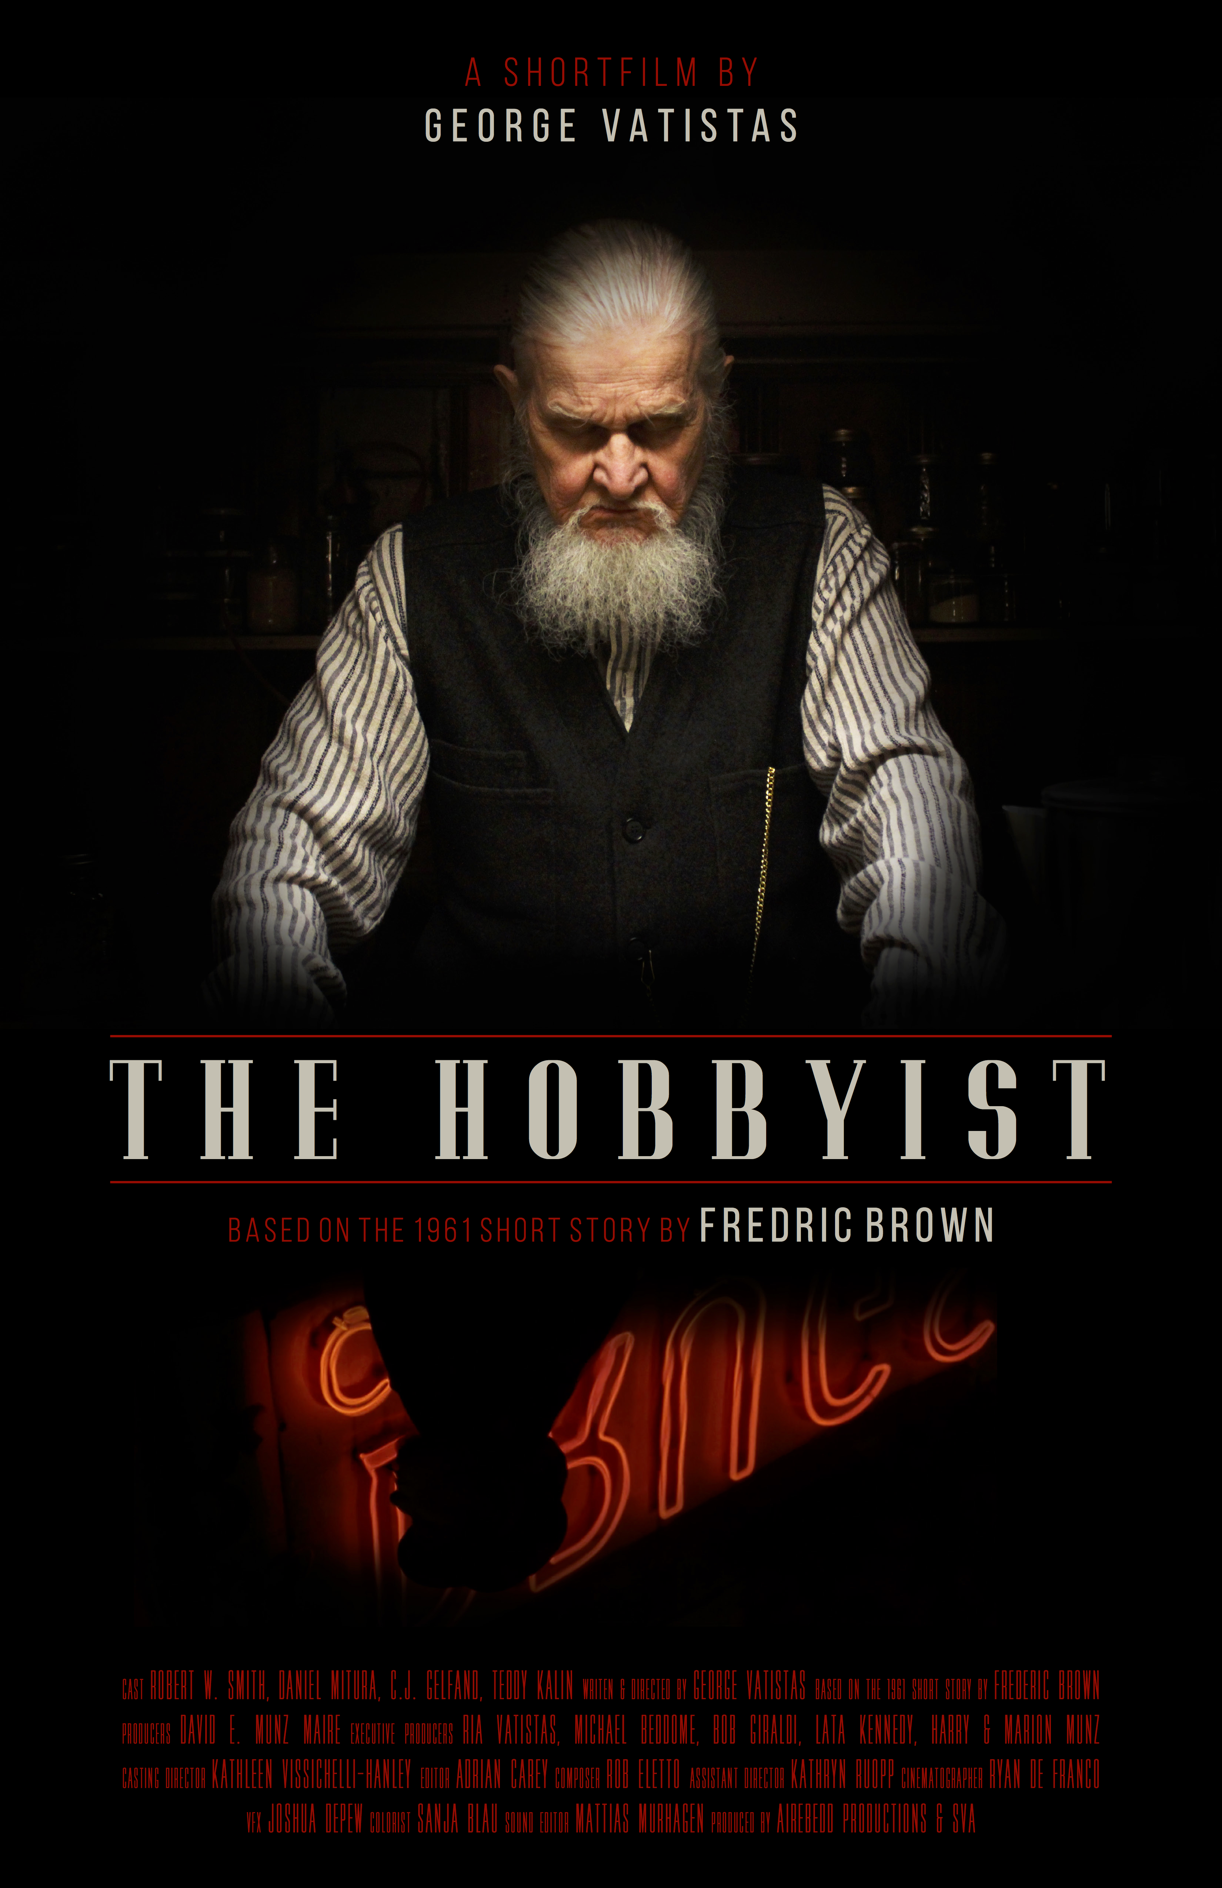

BANNER:

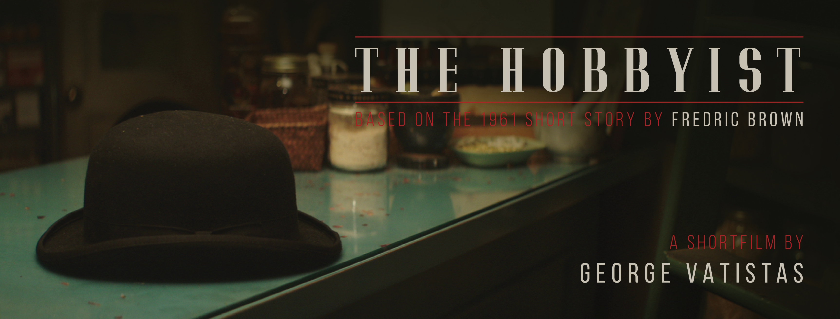
REVIEWS:

“A highly stylized short that is really a fun film to watch as the audience is very quickly taken by the mysterious characters and their dubious needs. Actor Robert W. Smith as the Druggist is simply fantastic and immediately pulls viewers into the narrative. The twisted story of poison, murder and deceit is pure entertainment and stands as a testament to [the] creative vision for the film! Definitely a must watch for all!”
– Sam Avery, Blackbird Film Festival
www.imdb.com/title/tt6249648/

“A short film that packs a big punch, blending the perfect mix of creepy and pleasing to match its dark yet purposeful message... with cinematically beautiful shots and a soundtrack that will keep you on the edge of your seat.”
– Melanie Davis, New Hope Film Festival
http://newhopefilmfest.blogspot.com/2017/05/the-hobbyist.html

“Bold and immediately catches one’s interest. ... Clever, well-timed. ... Tense yet enjoyable. Robert W. Smith captivates as the character of the Druggist. His performance lends a feel of mystery and fable to the entire film, and is inspired. Casting Director Kathleen Hanley... deserves kudos for finding such an adept actor to bring this role to life. Smith expertly paces his lines, never rushing, which aids in the film’s delivery of suspense. Daniel Mitura also does a great job as Sangstrom, conveying shifting emotions under the ever-changing circumstances. … The pacing of the film is spot-on. … The production design is well-executed and enhances the story. ... It’s a very entertaining short film and makes me want to see what’s next for AireBedd.”
– Samantha Kolesnik, DecayMag
http://decaymag.com/movies/reviews/hobbyist-george-vatistas/24068/

“Robert W. Smith provides a creepy performance as the druggist in the film. His ominous voice really sells every line… Daniel Mitura also does a wonderful job in the role of Sangstrom. He expertly conveys the desperation of his character… This short has a great cinematic look. The warm lighting and rich color make it a pleasure to watch. The old-fashioned drug store setting is also of note. ‘The Hobbyist’ is suspenseful and engaging in an artistic way.”
– John Migliore, Indie Horror Online
https://indiehorroronline.wordpress.com/2018/11/15/the-hobbyist-2016/

“Fantastic performance by [Robert W. Smith]… Best performance of the night… Very well thought out… It has power… Timeless and chilling, but really fascinating!”
– Audience Members, WildSound Feedback Film & Screenplay Festival 2018
https://www.youtube.com/watch?v=CQSYkKVyqhk

“Impressive with its powerfully packed, hearty plot... From the lighting to the set design, each element is appealing to the eye... fiendishly noble.”
– Michelle MIDI Peifer, House of Tortured Souls
https://houseoftorturedsouls.com/an-introduction-to-airebedd-productions/
“’The Hobbyist’ serves as Vatistas’s debut short film and it’s an impressive one at that. Cinematographer, Ryan De Franco has built quite a career in short filmmaking and his vast skillset is well and truly on display here. Everything is nicely framed and the shot choices are simple but productive. The audio track is controlled and Robert Eletto’s score is something entirely new. He invokes a sort of magical essence to the sound of keys and adds what sounds like individually plucked notes on a harp. Mitura and Smith’s performances are lively. … The camera work is slick, the audio is clean, and Eletto’s score is one of the standout features. … All in all, this is a great little film!”
– Adam Paul Weber, Adam The Movie God
https://adamthemoviegod.com/the-hobbyist-review-be-careful-what-you-wish-for/

“Equally, if not more so, haunting than the story it's based off of. The short stars a convincing Daniel Mitura playing Sangstrom. Alongside him stars Robert W. Smith who plays the unnerving Druggist. Between the two of them, their chemistry is undeniable. … Truly eye-catching. … The use of dark greens and dark browns absolutely sell the vintage drug store … [and] the entire environment in which the story is set in. Also, complimenting the entire environment is the director of photography Ryan De Franco and composer Roberto Eletto. Coupling the way the camera moves with eerie score helps in your mind's commitment to the story, the characters, and surroundings. … All involved have a bright future in filmmaking.”
– Sean Ellis, Crypt Teaze
https://www.crypt-teaze.com/single-post/2019/01/28/ReviewPodcast-George-Vatistas-Short-Film-The-Hobbyist

“In under nine minutes, George Vatistas builds an immersive world that’s strange, stylish, and completely captivating, with a score that lingers and production design that dazzles.”
- Céd Hopkins, FABA Films Festival Founder & Coordinator
https://medium.com/@cedhopkins/no-boxes-just-art-why-we-chose-not-to-divide-our-film-festival-awards-by-gender-or-race-cecbc5391951

“An excellent film all the way through the story, technical and performance aspects.”
– Nicole Ayers, Short Film Slam presented by Madlab Post

“What a gorgeous film. We really enjoyed the story, the premise and the telling of this tale.”
– Dr. Lighthouse, Delirium, Dreams & Nightmares

“A film that demonstrates the director's unparalleled creative vision, breathing life into a mesmerizing world… The use of visual motifs throughout the film adds a cohesive and visually striking element to the storytelling… The film is a work of art, skillfully blending visuals, sound, and storytelling to create a truly immersive cinematic experience.”
– Anonymous Judges, Student World Impact Film Festival
“In a word, superb. Wonderfully acted and directed. First class production design, camerawork, edit and sound.”
– Anonymous Judge, Transparent Film Festival

“The film was phenomenal… The premise and visual execution are entertaining and have a specific aesthetic. Rich tones and intriguing compositions in the cinematography made this easy to watch!... Certainly, the most admirable aspect of ‘The Hobbyist’ is its ability to craft a "cinematic tale" … showing no weakness in building a world detached from our present. This film overflows with formal and aesthetic creativity, steadily building a well-structured story that shines through the strength of its world and characters. From its cinematography to a superb production design and outstanding direction, ‘The Hobbyist’ is a breath of fresh air—familiar yet undeniably renewed by its visual beauty and the director’s skillful use of cinematic language.”
– Anonymous Judges, FABA Films Festival

“’The Hobbyist’ is a pitch-perfect neo-noir thriller from start to finish. From the very first moment—the trailer, the opening scene, the score, everything signals a filmmaker in complete control of tone, genre, and style. George Vatistas has crafted something truly exceptional. The direction is assured, the pacing tight, and the mood immersive. This is a filmmaker who clearly understands the language of noir and executes it with sophistication and restraint. The cinematography is moody and elegant, perfectly suited to the period piece setting. The music underscores every moment with the right amount of tension and flair, elevating the film’s impact without ever overpowering it. The acting is strong across the board, and the dialogue is delivered with precision and weight. There’s an authenticity to the characters and performances that grounds the stylish aesthetic in real emotional stakes. ‘The Hobbyist’ is a masterfully crafted short. It’s atmospheric, intelligent, and thoroughly engaging. This is the kind of work that demands a feature-length follow-up, and I’ll be first in line to see it.
– Jae Taylor, 3 Dollar Films
SECURED DISTRIBUTION:

non-exclusive licensees – content delivery platform (media distribution system) – signatory date

- Kinolife, LLC – Kino Life Distribution (VOD - OTT) – February 2020

- Beehler Media, LLC – RoleCall Watch: Roku Channel (VOD - TV App & OTT) – May 2020

- JIFFA – JIFFA Indian TV Channel: Box Cinema (VOD - TV App & OTT) – October 2020

- SBCK Cinematic, LLC – Cinema Life (VOD - OTT) – December 2020

- Bridgwater Digital – Bridgwater TV (VOD - OTT) – July 2021

- BUEIFF ® – BUEIFF: ProChannel (VOD - OTT) – September 2021

- Vaulter LTD – paus.TV (VOD - OTT) – December 2021

- GoreDrome Pictures / The Peacockstale LTD – 3 Steps to Fear (MOD - DVD & Blu-Ray) – December 2021

- Latest TV & Northern Visions NVTV – Latest Visions & Sheffield Live! (Broadcast TV in U.K. + Ireland & VOD - OTT) – August 2023

- Latest TV – Indie FilmOnTV (Broadcast TV in U.K.) – January 2024

- Troma Entertainment, Inc. – Troma NOW (VOD - TV App & OTT) – February 2024

- Leomark Studios, LLC – Hollywood Horror Fest Presents: Boobs & Blood (MOD - DVD & VOD - OTT) – January 2025

- Dread Sanctum AB – Dread Sanctum (VOD – OTT) – January 2025

- Screen Indie – Screen Indie (VOD – OTT) – January 2025

- Atlanta Film Series – FestFlix TV (VOD – OTT) – April 2025

- Short Frame LTD – Short Frame (VOD - OTT) – June 2025

FESTIVAL SCREENING DATA:

Number of Continents Screened On: 6x

Events Screened at Per Continent:
7x Africa
15x Asia
58x Europe
146x North America
3x Oceania
7x South America

Number of Countries Screened In: 38x

Events Screened at Per Country:
138x U.S.A.
15x Italy
9x England
7x India
6x Turkey
5x Canada
4x Brazil
3x Australia
3x France
3x Germany
3x Mexico
3x Nigeria
3x Spain
3x South Korea
2x Chile
2x Denmark
2x Ireland
2x Japan
2x Portugal
2x Romania
2x Russia
1x Argentina
1x Bangladesh
1x Belgium
1x Egypt
1x Georgia
1x Greece
1x Kenya
1x Malaysia
1x Morocco
1x Netherlands
1x Norway
1x Poland
1x Scotland
1x South Africa
1x Sweden
1x Thailand
1x Ukraine
8x* Virtual/ Online

U.S. States Screened In (Washington D.C. included): 30x

Events Screened at Per U.S. State:

29x New York
22x California
8x Florida
7x Michigan
7x North Carolina
7x Pennsylvania
6x Georgia
6x New Jersey
5x Texas
5x Washington
4x Illinois
4x Maryland
4x Wisconsin
3x Connecticut
3x Ohio
2x Kentucky
2x Oregon
2x Utah
1x Alabama
1x Colorado
1x Indiana
1x Maine
1x Massachusetts
1x Minnesota
1x Missouri
1x Nevada
1x New Mexico
1x North Dakota
1x Virginia
1x Washington D.C.

City with Highest Number of Screenings: New York City 20x

City with the 2nd Highest Number of Screenings: Los Angeles 15x
ACCOLADES:

Award Winner

- Paula Rhodes Memorial Award – SVA Short Film Fest 2016
- Best Fantasy – Mediterranean Film Festival 2017
- Silver Remy Award Shorts – Suspense/Thriller – WorldFest – Houston International Film & Video Festival 2017
- Best Student Film – Black Cat Picture Show 2017
- Best Action/Thriller Short Film – GenreBlast Film Festival 2017
- Best Long Narrative – Gotham Film Festival 2017
- Best Student Film – Another Hole In the Head 2017
- Best Narrative Short – College – Garden State Film Festival 2018
- Best Cinematography – Jim Thorpe Independent Film Festival 2018
- Best Performances – WildSound Feedback Film & Screenplay Festival 2018
- Best Cinematography – Liberty Massacre 2018
- Best Production Design – Wreak Havoc Film Festival 2018
- 3rd Place Best Suspense Short – Indie Suspense Horror Sci-Fi Film Festival 2018
- Best Student Film - LIFFT India Filmotsav-World Cine Fest 2018
- Best Short – Stormy Weather Horror Film Fest 2019
- Best Actor (Robert W. Smith) – Stormy Weather Horror Film Fest 2019
- Best Sound / Music – Stormy Weather Horror Film Fest 2019
- Award Winner – NanoCon International Science-Fiction Film Festival 2019
- Audience Choice Award – Lit On Film – Strand Books & Nitehawk present the Annual Literary Film Fest 2019
- Best Cinematography – Video Hackers Film Festival 2019
- Best NY Student Film – Upstate NY Horror Film Festival 2019
- Best Actor: University Category – Festival Internacional de Cinema Escolar de Alvorada 2019
- Best Student Film – Frostbite International Indie Fest 2019
- Best Original Score – Frostbite International Indie Fest 2019
- Best Short Horror – Ocean City Film Festival 2020
- Best Short Film – Noir – Blu-Hill Film Festival 2020
- Best Horror – Down East Flick Fest 2020
- Best Sound Design – Maine Student Film Festival 2020
- Best Student Film – End of Days Film Festival 2021
- Best of the Fest - YellowHammer Film Fest 2021
- Best Cinematography - YellowHammer Film Fest 2021
- 3rd Prize Best Fiction Film - Sakarya International Short Film Festival 2021
- Best Short Film – The Thing in the Basement Horror Fest 2021
- Best Score – Hardcore Horror Fest 2021
- Best Cinematography – Chainsaw Game & Music Festival 2021
- Viewer's Favorite – The Fear Faire Film Festival 2022
- Judge’s Choice – The Fear Faire Film Festival 2022
- Best Director of Student Film – Brazil International Monthly Independent Film Festival 2022
- Best Actor of Student Film (Robert W. Smith) – Brazil International Monthly Independent Film Festival 2022
- Best Editing of Student Film – Brazil International Monthly Independent Film Festival 2022
- Best Production Design – Sugar Loaf Film Festival 2022
- Best International Film – Brejning Film Festival 2022
- Best Actor (Robert W. Smith) – Brejning Film Festival 2022
- Mucky Award for Best Film Twist – 573 Short Film Festival 2022
- Best Director – Short Film – Ipê Amarelo Film Festival 2022
- Best Lead Actor (Robert W. Smith) – Short Film – Ipê Amarelo Film Festival 2022
- Best Cinematography – Short Film – Ipê Amarelo Film Festival 2022
- Best Production Design – Short Film – Ipê Amarelo Film Festival 2022
- Best Horror/Thriller – David Film Festival 2023
- Best Actor/Actress (Robert W. Smith) – David Film Festival 2023
- Best Cinematography – David Film Festival 2023
- Best Thriller Film – Aasha International Film Festival 2023
- Best Production Design – Electric Film Festival 2024
- Jury Award – Best Spoopy Short – Kinda Spoopy 2024
- Best Short Film – Southeast Asia International Film Festival 2024
- Best Original Score – FABA Films Festival 2025
- Best Production Design – FABA Films Festival 2025
(as of 28th May 2025)

Nominated Finalist

- Best Cinematography – Hang Onto Your Shorts Film Festival 2017
- Best Short Film – LIIFE - Long Island International Film Expo 2017
- Best Student Film – New Hope Film Festival 2017
- Best Concept of a Short – Northeast Film Festival 2017
- Best Short – Northeast Film Festival 2017
- Best Actor (Robert W. Smith) - Short Film – GenreBlast Film Festival 2017
- Best Film Award – Middlesbrough International Film Festival 2017
- Best Fantastic Student Film – FilmQuest 2017
- Best Student Short – FilmQuest 2017
- Best Short Film – Edmonton Festival of Fear: Horror, Sci-Fi, Action & Cult Movies 2017
- Best Actor (Robert W. Smith) – Edmonton Festival of Fear: Horror, Sci-Fi, Action & Cult Movies 2017
- Best Actor (Daniel Mitura) – Edmonton Festival of Fear: Horror, Sci-Fi, Action & Cult Movies 2017
- Best Production Design – Jim Thorpe Independent Film Festival 2018
- Semi-Finalist – Nassau Film Festival 2018
- Semi-Finalist – San Mauro Torinese International Film Festival 2018
- Best Picture – L.A. Neo Noir Novel, Film & Script Fest 2018
- Top 5 – Short Film Slam: Presented by the Madlab Post 2018
- Best Short Film : Suspense/Horror – Art is Alive Film Festival 2018
- Best Actor : Male (Robert W. Smith) – Art is Alive Film Festival 2018
- Honorable Mention Best Student Short Film – The Golden Skull Film Festival 2018
- Best Drama - The Melbourne Independent Filmmaker’s Festival 2018
- Best Cinematography - The Melbourne Independent Filmmaker’s Festival 2018
- Best Production Design - The Melbourne Independent Filmmaker’s Festival 2018
- Best Bizarre Film – The Optical Theater Horror Film Festival 2018
- Best Noir Short – Genre Celebration Festival 2018
- Best Cinematography – Genre Celebration Festival 2018
- Semi-Finalist – Los Angeles CineFest 2019
- Best Director – Stormy Weather Horror Film Fest 2019
- Best Short Horror/Horror Comedy – Take It Easy Film Festival 2019
- “Strong as Heck” Hammer Award – SBE’S Hamilton (New York) International Film Festival 2019
- Best Short Student Film – Galata Frame International Film Festival 2019
- Best Actor (Robert W. Smith) – Galata Frame International Film Festival 2019
- Ghoul Days: Best Student Film – Spook Screen Film Festival 2019
- Best Act-Roar (Robert W. Smith) – Spook Screen Film Festival 2019
- Semi-Finalist – Lisbon Film Rendezvous 2019
- Finalist – The Annual Mountain Shadow Short Film Competition 2019
- Best Fiction Short – Zaporizhzhia International Film Festival 2019
- Finalist – Las Vegas Global Film Convention 2019
- Best Non-Post Apocalyptic Drama – Wasteland Film Festival 2019
- Finalist – Southeast Regional Film Festival 2020
- Semi-Finalist – Realtime International Film Festival 2020
- Finalist – Longless Film Festival 2020
- Best Made In NY (Student) Short – Twin Tiers International Film Festival 2020
- Best Picture – Maine Student Film Festival 2020
- Semi-Finalist – Mitreo Film Festival 2020
- Finalist - Delirium, Dreams & Nightmares 2020
- Semi-Finalist – The Next Level International Film Festival 2021
- Quarter Finalist – Volterra Fantasy Film Festival 2021
- Semi-Finalist – Best Cinematography – The Thing in the Basement Horror Fest 2021
- Best Director – Hardcore Horror Fest 2021
- Best Screenplay – Hardcore Horror Fest 2021
- Best Actor (Robert W. Smith) – Hardcore Horror Fest 2021
- Best Cinematography – Hardcore Horror Fest 2021
- Best Editing – Hardcore Horror Fest 2021
- Honorable Mention - Sanctuary International Film Festival 2021
- Best Short Film – Derby Film Festival 2021
- Quarter-Finalist – Aporia International Village Film Festival 2021
- Best Student Film – Brazil International Monthly Independent Film Festival 2022
- Best Screenplay of Student Film – Brazil International Monthly Independent Film Festival 2022
- Best Sound Design of Student Film– Brazil International Monthly Independent Film Festival 2022
- Best Cinematography of Student Film – Brazil International Monthly Independent Film Festival 2022
- Best Production Design of Student Film – Brazil International Monthly Independent Film Festival 2022
- Best Supporting Actor of Short Film (Daniel Mitura) – Brazil International Monthly Independent Film Festival 2022
- Best Poster – Brazil International Monthly Independent Film Festival 2022
- Best Trailer – Brazil International Monthly Independent Film Festival 2022
- Bester Post-Production – Brazil International Monthly Independent Film Festival 2022
- Best Thriller/ Sci-Fi Film – Bridgeport Film Fest 2022
- Best Cinematography – Bridgeport Film Fest 2022
- Semi-Finalist – The Independent Film and Art Festival 2022
- Semi-Finalist – Festival del Cinema di Cefalù 2022
- Honorable Mention – Film Night On Fulton 2022
- Finalist – Best Film – Brejning Film Festival 2022
- Finalist – Best Drama – Brejning Film Festival 2022
- Quarter Finalist – Lil’ Spooky Fest 2022
- Finalist – Horror Island 2022
- Best Film – The Black Country Horror Shorts Film Festival 2022
- Best Short Film – TopShot International Film Festival 2022
- Student Film – TopShot International Film Festival 2022
- Best Thriller – TopShot International Film Festival 2022
- Best Actor (Robert W. Smith) – Busan New Wave Short Film Festival 2023
- Best Cinematography – Korea International Short Film Festival 2023
- Creative Individuality Award – Framing the Needle Film Festival 2023
- Best Editing – Framing the Needle Film Festival 2023
- Best NYC Film – Transparent Film Festival 2023
- Best Short Film Award – Student World Impact Film Festival 2023
- Finalist – Best Short Film – The FilmJoint 2023
- Finalist – Best Short Film - Student – Los Angeles CINEVERSE Film Fest 2023
- Best Short Film – A Royal Chance Film Festival 2024
- Best Suspense Thriller Film Award – Austin Short Film Festival 2024
- Semi-Finalist – Best Short Film – Kalaburagi International Film Festival 2024
- Honorable Mention & Quarter-Finalist – Best Short Film – WideScreen Film & Music Video Festival 2024
- Finalist – Best Student Film – Twelve Lions Film Festival 2024
- Empire State Award – Wicked Realm Film Festival 2024
- Quarter-Finalist – Highlands-Cashiers Film Festival 2025
(as of 22nd February 2025)
Official Selections

- SVA Short Film Fest 2016
- Twin Rivers Media Festival 2017
- The Mediterranean Film Festival 2017
- Cleveland International Film Festival 2017
- Short to the Point 2017
- Move Me Productions Belgium – Short Film Festival 2017
- WorldFest – Houston International Film & Video Festival 2017
- NYC Independent Film Festival 2017
- Hang Onto Your Shorts Film Festival 2017
- Dances With Films 2017
- Art of Brooklyn Film festival 2017
- Lighthouse International Film Festival 2017
- FFOCOL – Film Festival of Columbus 2017
- Katra Film Series 2017
- LifeArt Media Festival 2017
- Cryptshow Festival 2017
- Atlanta Shortfest 2017
- LIIFE – The Long Island International Film Expo 2017
- New Hope Film Festival 2017
- SAFILM – San Antonio Film Festival 2017
- The Kew Gardens Festival of Cinema 2017
- New York Film Screenings 2017
- Artists & Beers Presented by Dean Street 2017
- Black Cat Picture Show 2017
- Burbank International Film Festival 2017
- GenreBlast Film Festival 2017
- Northeast Film Festival 2017
- FilmQuest 2017
- Middlesbrough International Film Festival 2017
- Mykonos Biennale 2017
- Tri-Cities International Film Festival 2017
- Beacon Independent Film Festival 2017
- Fargo Fantastic Film Festival 2017
- Hell’s Half Mile Film & Music Festival 2017
- Lilliputian Film Festival 2017
- Edmonton Festival of Fear: Horror, Sci-Fi, Action & Cult Movies 2017
- Shiver International Film Festival 2017
- Another Hole In the Head 2017
- The Overkill Festival 2017
- Blow-Up Arthouse Film Festival 2017
- Buffalo Dreams Fantastic Film Festival 2017
- HorrorHaus Film Festival 2017
- Gotham Film Festival 2017
- Shivers Film Festival 2017
- Nevermore Film Festival 2018
- Garden State Film Festival 2018
- Red Corner Film Festival 2018
- Media Film Festival 2018
- Jim Thorpe Independent Film Festival 2018
- WILDsound Feedback Film and Screenplay Festival 2018
- Cefalù Film Festival 2018
- New Haven International Film Festival 2018
- Nassau Film Festival 2018
- San Mauro Torinese International Film Festival 2018
- L.A. Neo Noir Novel, Film & Script Festival 2018
- Short Film Slam: Presented by the Madlab Post – Philadelphia, PA 2018
- Weird Wednesday 0711 2018
- Bad Film Fest 2018
- Cape Fear Independent Film Festival 2018
- Threadbare Mitten Film Festival 2018
- San Benedetto Film Fest 2018
- Liberty Massacre – Presented by Average Superstar Films 2018
- Short Film Slam: Presented by the Madlab Post – Baltimore, MD 2018
- Something Wicked Film Festival 2018
- Chain NYC Film Festival 2018
- Art is Alive Film Festival 2018
- D.C. Shorts Film Festival and Screenplay Competition 2018
- Melrose Film Festival 2018
- Wreak Havoc Horror Film Festival 2018
- The Golden Skull Film Festival 2018
- Shriekfest 2018
- Indie Suspense Horror Sci-Fi Film Festival 2018
- KisaKes Short Film Festival 2018
- Orlando Film Festival 2018
- The Melbourne Independent Filmmaker’s Festival 2018
- HorrorQuest Film Festival 2018
- Northern Frights Festival 2018
- Halloween International Film Festival 2018
- Horror Film Thursdays 2018
- Miami FearFest 2018
- The Optical Theater Horror Film Festival 2018
- Genre Celebration Festival 2018
- InShort Film Festival 2018
- LIFFT India Filmotsav-World Cine Fest 2018
- Horror-on-Sea 2019
- Green Bay Film Festival 2019
- Los Angeles CineFest 2019
- Winter Film Awards 2019
- Cleveland Concoction 2019
- Stormy Weather Horror Film Fest 2019
- NanoCon International Science-Fiction Film Festival 2019
- Third Eye Film Festival 2019
- Boston International Film Festival 2019
- Capital City Film Festival 2019
- LiftOff: First-Time Filmmaker Sessions 2019
- International University Festival Cine- Literature of Agadir 2019
- Take It Easy Film Festival 2019
- MayDay Film Festival 2019
- The Chaffey Review Film Festival 2019
- Calgary Horror Con 2019
- SBE’S Hamilton (New York) International Film Festival 2019
- Galata Frame International Film Festival 2019
- Lit On Film – Strand Books & Nitehawk present the Annual Literary Film Fest 2019
- Slum Film Festival 2019
- Spookscreen Film Festival 2019
- Lisbon Film Rendezvous 2019
- The Annual Mountain Shadow Short Film Competition 2019
- Zaporizhzhia International Film Festival 2019
- Video Hackers Film festival 2019
- Las Vegas Global Film Convention 2019
- Wasteland Film Festival 2019
- BAM! Festival 2019
- Local Haunts: Horror Short Film Showcase 2019
- Upstate NY Horror Film Festival 2019
- The Fatherhood Image Film Festival 2019
- Southeast Michigan Film Festival 2019
- Festival Internacional de Cinema Escolar de Alvorada 2019
- Caminhos Film Festival 2019
- Frostbite International Indie Fest 2019
- International Short & Independent Film Festival, Dhaka 2019
- Dunedin International Film Festival 2020
- Cortokino 2020
- Ocean City Film Festival 2020
- Southeast Regional Film Festival 2020
- FLICKFAIR 2020
- Ufa Youth Short Film Festival 2020
- Realtime International Film Festival 2020
- Speculative Film Fest 2020
- RoleCall 2020
- Desertscape International Film Festival 2020
- Ravenheart International Film Festival 2020
- Longless Film Festival 2020
- Portobello Film Festival 2020
- Twin Tiers International Film Festival 2020
- Friends of Oshkosh Film Festival 2020
- Blu-Hill Film Festival 2020
- Down East Flick Fest 2020
- Milwaukee Twisted Dreams Film Festival 2020
- Jharkhand International Film Festival & Awards 2020
- Maine Student Film Festival 2020
- Highlands Film Fest 2020
- Sit Down Shutup and Watch Film & New Media Festival 2020
- Dead in Decatur presents: the Art of Fear 2020
- Mitreo Film Festival 2020
- Bleedingham Horror Film Festival 2020
- Sardar Vallabhbhai Patel International Film Festival 2020
- Delirium, Dreams & Nightmares 2020
- Reel Horror Fest 2020
- Reel East Texas Film Festival 2020
- The Next Level International Film Festival 2021
- McMinnville Short Film Festival 2021
- Scream It Off Screen 2021
- End of Days Film Festival 2021
- Volterra Fantasy Film Festival 2021
- AmiCorti Film Festival 2021
- Blackbird Film Festival 2021
- Bridgwater TV – online film festival 2021
- YellowHammer Film Fest 2021
- Smiles Film Festival 2021
- Anatolia International Film Festival 2021
- Four Corners Film Festival 2021
- Buenos Aires International Film Festival 2021
- Sakarya International Short Film Festival 2021
- Alumbra. Festival de Cortometrajes "Ciudad de Hellín" 2021
- Sacalacalaca Interdimensional Horror & Sci-Fi Festival 2021
- Heroes International Film Festival 2021
- The Thing in the Basement Horror Fest 2021
- Hardcore Horror Fest 2021
- Sanctuary International Film Festival 2021
- Derby Film Festival 2021
- Aporia International Village Film Festival 2021
- Chainsaw Game & Music Festival 2021
- Festival Internacional De Cine De Terror Valparaiso 2021
- The Paus Premieres Festival 2021
- Festival RENUAC 2022
- Golden Bridge İstanbul Short Film Festival 2022
- Festival RNAB 2022
- The Fear Faire Film Festival 2022
- Brazil International Monthly Film Festival 2022
- Bridgeport Film Fest 2022
- The Independent Film and Art Festival 2022
- Festival del Cinema di Cefalù 2022
- Tournadeau Music and Film Festival 2022
- Techirghiol Art Festival 2022
- Sugar Loaf Film Festival 2022
- Film Night on Fulton 2022
- Brejning Film Festival 2022
- 573 International Short Film Festival 2022
- Midwest Sci-Fi Short Film Festival 2022
- Lil' Spooky Fest 2022
- Horror Island 2022
- Skiptown Playhouse International Film Festival 2022
- The Black Country Horror Shorts Film Festival 2022
- The Flint Short Film Freakout 2022
- TopShot International Film Festival 2022
- Ipê Amarelo Film Festival 2022
- Busan New Wave Short Film Festival 2023
- Korea International Short Film Festival 2023
- RapidLion - The South African International Film Festival 2023
- Allentown Film Festival 2023
- Meihodo International Youth Visual Media Festival 2023
- Framing the Needle Film Festival 2023
- Transparent Film Festival 2023
- Bloody Hats Film Festival 2023
- Student World Impact Film Festival 2023
- The FilmJoint 2023
- International Short & Symbolic Art Film Festival 2023
- Los Angeles CINEVERSE Film Fest 2023
- Villammare Festival Film & Friends 2023
- Bay Area Cinema 2023
- Student Live Film Festival 2023
- Animal Film Fest 2023
- Latest Visions presents: Halloween Special 2023
- Copenhagen Short Film Festival 2023
- East Lansing Film Festival 2023
- David Film Festival 2023
- Kixta Fest 2023
- Aasha International Film Festival 2023
- A Royal Chance Film Festival 2024
- Austin Short Film Festival 2024
- DaVinci International Film Festival 2024
- Rising Tide Film Festival 2024
- Kalaburagi International Film Festival 2024
- Cine RO - Rondônia Film Festival 2024
- Electric Film Festival 2024
- WideScreen Film & Music Video Festival 2024
- Twelve Lions Film Festival 2024
- That Film Festival 2024
- Kinda Spoopy 2024
- Wicked Realm Film Festival 2024
- British University International Students Film Festival 2024
- Valle D'Itria Film Festival - Festival per la Pace 2024
- Southeast Asia International Film Festival 2024
- Court-Métrages Scène Ouverte 2025
- Ahmedabad International Film Festival 2025
- Monteatro e Dintorni d'Arte 2025
- Balticon Sunday Short Science Fiction Film Festival 2025
- FABA Films Festival 2025
- Rencontres de Cinéma de Mirepeisset 2025
- Short Frame 2025
- Festival Angaelica 2025
- Highlands-Cashiers Film Festival 2025
- Port of Fear Film Festival 2025
- Kuala Lumpur International Film Academy Awards 2025
(as of 01st September 2025)

DIRECTOR’S STATEMENT:

At its core, filmmaking is an art that thrives on the perpetual dance between the legacy of the past and the innovation of the present. My journey with "The Hobbyist," which stands as the requisite graduate thesis for my Master's in Directing, is a vivid testament to this delicate interplay.

My affinity for Fredric Brown's storytelling was kindled with a previous short film, "The Weapon," which marked my initial foray into the rich narrative universe of this celebrated author. I have always been captivated by Brown's ability to weave the ordinary with the extraordinary, to ensnare the mind with compelling twists and resonant human themes. Thus, when the opportunity arose to delve into another of his creations for my thesis, it felt like a natural progression—a chance to deepen the relationship between adapter and source material.

"The Hobbyist" is more than an adaptation; it is a re-imagining, a conduit through which Brown's narrative brilliance is both honored and revitalized. The story beckoned me with its latent aesthetic potential—a potential I sought to fully realize through the medium of film. My vision was to craft a cinematic experience that encapsulates the suspense and the subtext of Brown's work, to create a piece that is as visually arresting as it is narratively compelling.

I am profoundly proud to present "The Hobbyist" to a global audience of like-minded individuals who share a passion for stories that challenge, entertain, and endure. This film is a labor of love, a tribute to the timeless allure of good storytelling, and a showcase of the artistic growth I have undergone during my tenure at the School of Visual Arts.

As you watch "The Hobbyist," I invite you to immerse yourself in the world I have envisioned, to find yourself lost in the layers of intrigue, and to appreciate the subtle threads that bind us to the craft of storytelling. It is a story that transcends the confines of its pages, taking on a new life in the realm of the visual, and it is my hope that it resonates with you, as it did with me.

Thank you for accompanying me on this cinematic journey.

- George Vatistas
ACTOR BIOGRAPHIES:

ROBERT W. SMITH
as The Druggist

After retiring from the health department he has once again become involved in acting. In the past seven years he has appeared in four Off-Broadway plays, several staged readings and many films. He has also done voice over work for such productions as Grand Theft Auto V. Robert is a proud member of SAG-AFTRA and AEA.
IMDB: https://www.imdb.com/name/nm3343383/

DANIEL MITURA
as Sangstom

Daniel Mitura is an actor and writer living in New York City. Originally from Dallas, Texas, he has had several plays produced in New York as well as internationally. He is a graduate of Columbia University with he received his B.A. in Art History & Theater.
IMDB: https://www.imdb.com/name/nm3662035/
KEY CREW BIOGRAPHIES:

BOB GIRALDI
Executive Producer

Bob Giraldi is an American film and television director known for the films “Dinner Rush“ (2000), “Hiding Out” (1987), and the music video for Michael Jackson's song “Beat It.” His work has garnered many accolades, including several London International Awards, Cannes Advertising Awards, NY International Awards, Addy Awards, Chicago Film Festival Awards and hundreds of Clio Awards. He has also been named one of the "101 Stars Behind 100 Years of Advertising." He has produced and directed close to 3000 commercials, music videos and short films with his own production company, Giraldi Media.
IMDB: https://www.imdb.com/name/nm0320588/

D. M. NIGHT MAIRE
Producer

Cosmopolitan in nature, Night Maire (David E. Munz Maire) is an alumnus of the prestigious NYU: Tisch School of the Arts, earning his B.A. in Film & T.V. with a focus on Directing, and Minors in Psychology and Producing for Film & T.V. This native Alpine’s passion for directing led him to pursue a Masters in Directing at the School of Visual Arts under famed music video and commercial director Bob Giraldi. David Co-Founded AireBedd, a banner under which he has garnered hundreds of laurels and awards for his various short films and music videos, and produced content for Louis Vuitton Moet Hennessy, Red Bull and the Leslie-Lohman Museum amongst others.
IMDB: https://www.imdb.com/name/nm4731396/

GEORGE VATISTAS
Writer + Director

George is a Greek-American filmmaker who graduated from the New York College Film School in Athens, Greece. His first short movie “The Weapon” was praised by international self-taught director Pantelis Voulgaris. His passion for directing and cinema led him to New York City where George completed his Masters in Directing at the School of Visual Arts, under Bob Giraldi’s Directing Program.
IMDB: https://www.imdb.com/name/nm8584500/

RYAN DE FRANCO
Cinematographer

Ryan grew up in a Volvo 240 along the back roads of Inter State-75. His projects have screened at Cannes Film Festival and MoMa PS1, and his work has been featured in Interview Magazine, New York Magazine, Huffington Post, W Magazine, the Fader, Esquire, and the New York Times. In 2015, Ryan traveled to the front lines of the Iraq/ISIS conflict and across the Rwandan countryside — filming Jihan and Kagame, two interpersonal documentaries, both currently in Post-Production. At home in New York and Los Angeles, Ryan’s commercial clients include L’Oreal, Tourneau, Marriott, Sony, Ferrari S.P.A., Mac Cosmetics, Chandon, and Domaines Barons de Rothschild.
IMDB: https://www.imdb.com/name/nm3645884/

ROBERTO ELETTO
Composer

Roberto Eletto is a freelance creative professional who has produced music, maps, and writing for a wide variety of media. He is a graduate of The New School and Hunter College, completing an M.A. in Geographic Information Science Technologies at the latter. Mr. Eletto has scored several films for graduates of NYU’s Tisch School of the Arts, the School of Visual Arts, S.U.N.Y, and Columbia, among others.
IMDB: https://www.imdb.com/name/nm4526735/

KATHY RUOPP
Assistant Director

Kathy Ruopp is a filmmaker with experience, skills and good judgment, who delivers effective support of the creative and elevated execution of production. She works in New York City as a Producer, Production Manager and Assistant Director working in television and film, and taught Graduate Production at the School of Visual Arts in Bob Giraldi’s Live Action Short Film Program. She is a member of the Director’s Guild of America.
IMDB: https://www.imdb.com/name/nm0970084/

FULL CREW LIST:

Written & Directed by George Vatistas
Based on the 1961 short story by Frederic Brown
Producers: David M. Night Maire
Executive Producer: Ria Vatistas, Michael Beddome, Bob Giraldi,
Lata Kennedy, Harry & Marion Munz
Casting Director: Kathleen Vissichelli-Hanley
Editor: Adrian Carey
Composer: Rob Eletto
Assistant Director: Kathryn Ruopp
Cinematographer: Ryan de Franco
1st A.C.: Emma Hing
1st A.C.: Colton Huynh
2nd A.C.: Kelly Wurtz
D.I.T.: Adrian Carey
Gaffer: Konstantin Lyubimov
Key Grip: Ivannoff Santos
Best Boy Grip: Ryan Henry
Best Boy Electric: Stephanie Guzman
Sound Mixer: Naleeka Dennis
Production Designer: Kristina Palmer
Art Director: Jake Folsom
Set Decorator: Anastasia Baker
Prop Master: Emma Verner
Key Hair & Make Up Artist: Drishty Empire
VFX: Joshua Depew
Colorist: Sanja Blau
Sound Editor: Mattias Murhagen
Set Photographer: Joe Zakko
Graphic Designer: Alejandro Moyano
Key P.A.: Zach Hasselbring
P.A.: Luke Graglia
Catering: Rias Vatistas & Allyssa S. Rivera-Cabrero
Special Thanks: JoAnna Beckson, Alexander Dinelaris, Thomas Gall, Anelisa Garfunkel, Sharon Greytak, Sean Heilingoetter, Megan Hessenthaler, Laurence Kardish, Destiny Lilly, Barry N. Malzberg, Matthew Myslinski, Georgia Sakellariou, Richard Pepperman, Francesco Portinari, Phoebe Violet Greenberg, Sofia Sondervan, Epistimi Vatistas, Robert Vatistas, Caserta Eye, Handheld Films Inc., Eastern District Camera, Flower Power Herbs & Roots Inc., and JDC Wilmington Camera Service Inc.

Produced by AireBedd Productions & SVA MPS: Directing

CONTACT INFO:

SHORT FILM:
“The Hobbyist”
webpage : www.dmnightmaire.com/the-hobbyist
Short Frame screener : www.youtube.com/watch?v=cu8zv8vgr7E
Facebook : www.facebook.com/thehobbyistmovie
IMDb : www.imdb.com/title/tt6249648/

PRODUCER:
D. M. Night Maire
e-mail : dmnightmaire@gmail.com
cell : +1 (347) 366-1916
website : www.dmnightmaire.com
IMDb : www.imdb.com/name/nm4731396/
Insta : @dmnightmaire

